Tripping on aesthetascs
Figures of the experimental design
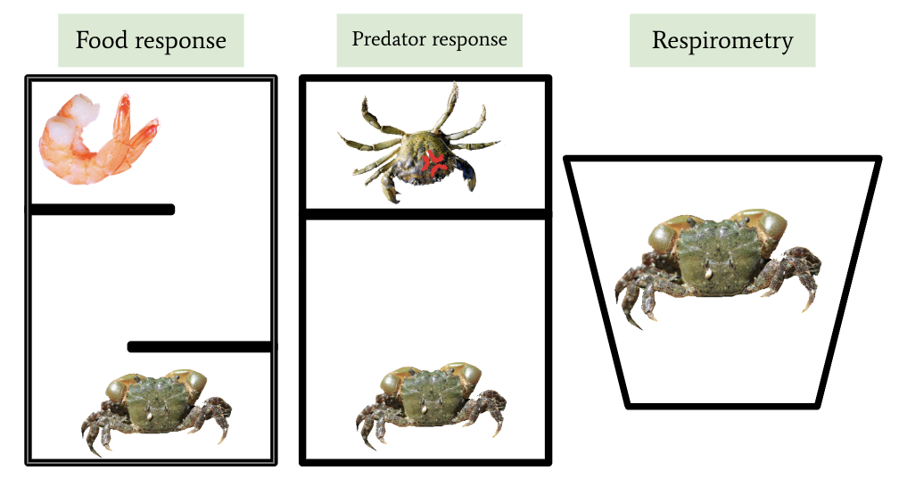
Food response: Hemigrapsus oregonensis in a maze tank. Put on one side, food will be placed on the other. The dividers can still be maneuvered around, while blocking the line of sight.
Predator response: H. oregonensis is placed in the larger side of the tank, while C. maenas is placed in the smaller section. The two crabs cannot see each other, but can smell each other in the water.
Respirometry: H. oregonensis is placed into a small pool of resazurin in order to do respirometry. See respirometry protocol for detailed intructions.

